Prometheus and Grafana Demo By deploying Web Application on Kubernetes Cluster
Here First we will create Kubernetes cluster and then in next step will install prometheus and Grafana to monitor the ec2 machines.

Step1 : Launch 3 Amazon Linux 2 ec2 machines(Master, node1 and node2) with t2.large Instance Type
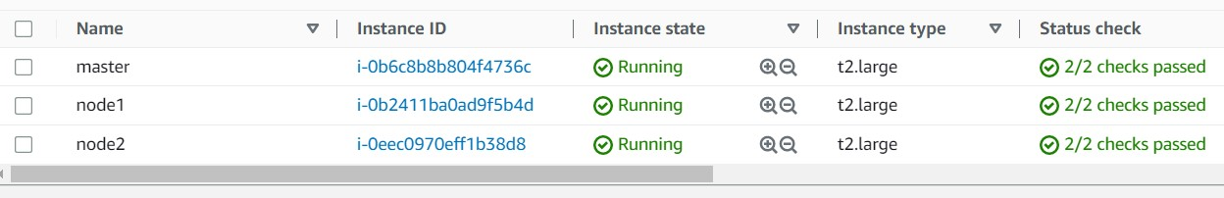

Step2 : Installing Docker and Kubernetes on master
- Switch to root user and create a file called master.sh with docker and Kubernetes installation commands in it.
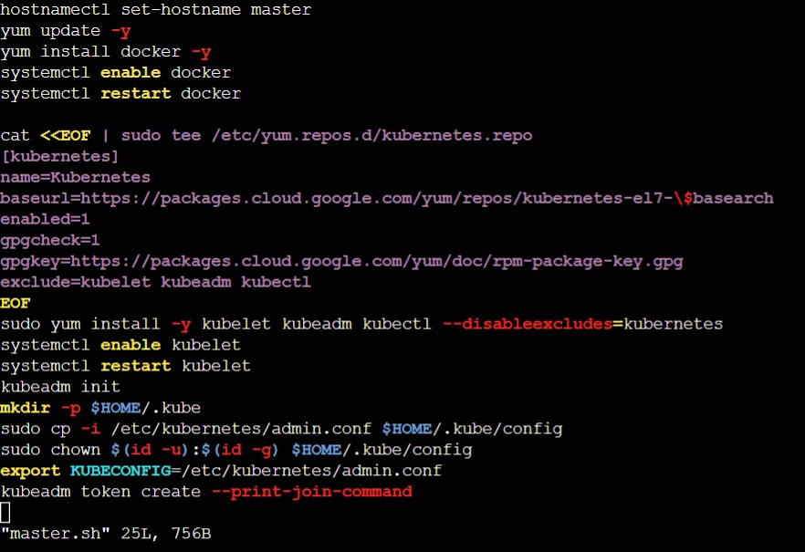
- Give execution permission to master.sh file
- #chmod +x master.sh
- Run the above master.sh file
- # ./master.sh

- After running master.sh file you will get kubeadm join command copy and keep, we will use that join command to join our nodes to master.
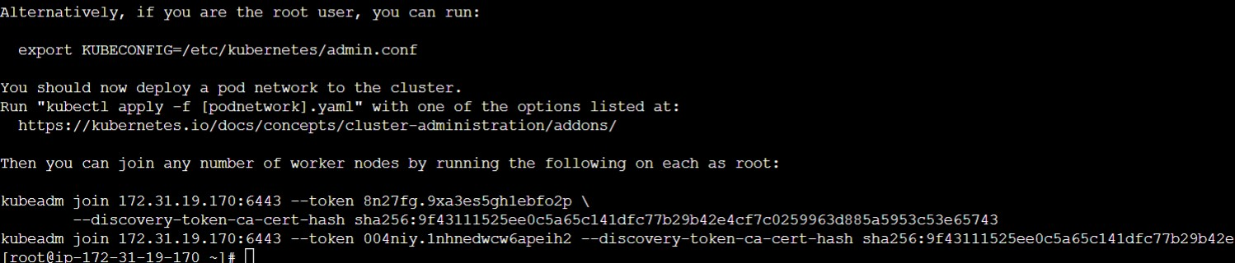

- Install git and Java
- # yum install git -y && amazon-linux-extras install java-openjdk11 -y

- Check git version and java version
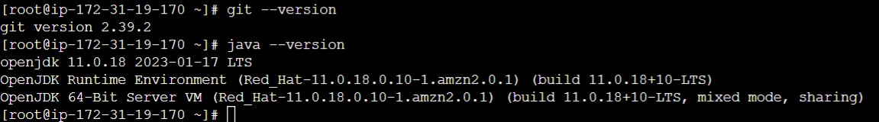

Step 3 : Adding node1 and node2 to Kubernetes master
- Open node1 ec2 machine and Switch to root user
- # sudo -i
- Create a file called node1.sh and put following commands in it. And give execute permission to node1.sh file.

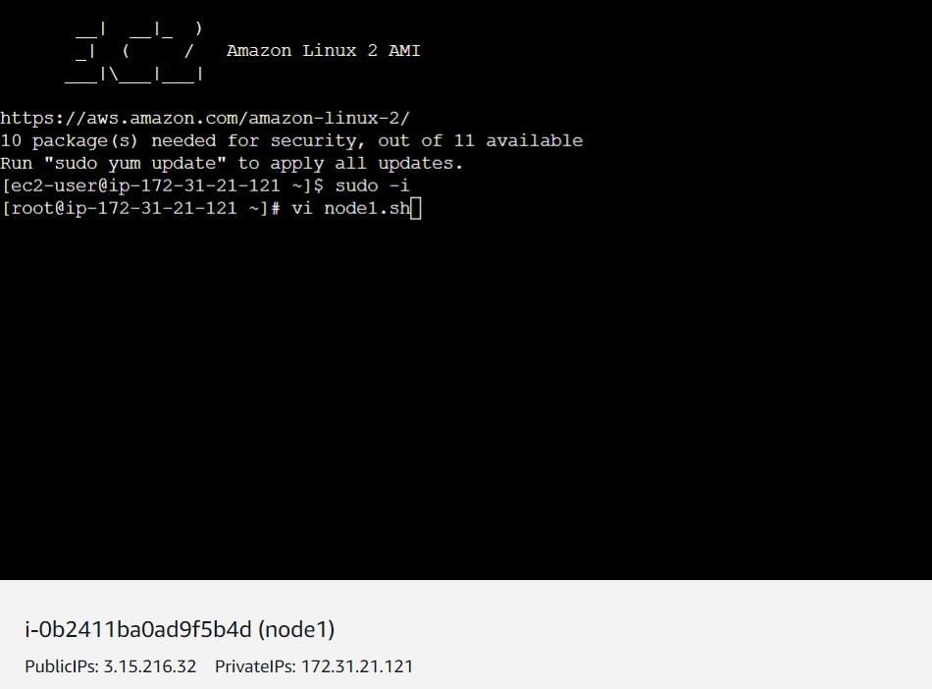
- Put these commands
hostnamectl set-hostname node1
yum update -y
amazon-linux-extras install java-openjdk11 -y
yum install git -y
yum install docker -y
systemctl enable docker
systemctl restart docker
cat <<EOF | sudo tee /etc/yum.repos.d/kubernetes.repo
[kubernetes]
name=Kubernetes
baseurl=https://packages.cloud.google.com/yum/repos/kubernetes-el7-\$basearch
enabled=1
gpgcheck=1
gpgkey=https://packages.cloud.google.com/yum/doc/rpm-package-key.gpg
exclude=kubelet kubeadm kubectl
EOF
sudo yum install -y kubelet kubeadm kubectl --disableexcludes=kubernetes
systemctl enable kubelet

systemctl restart kubelet

- Your file will look like this. Give execute permission to this file and run it.
- #chmod +x node1.sh
- # ./node1.sh
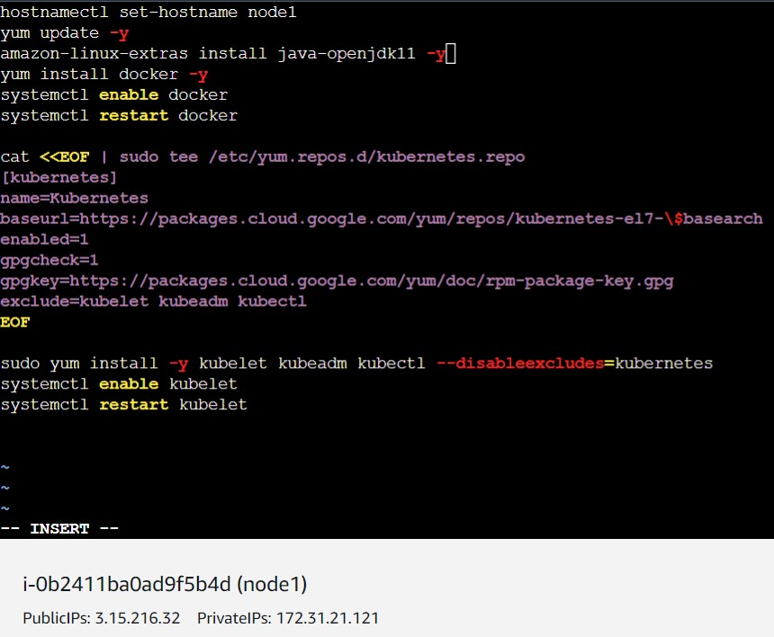

- If the above file is executed successfully you will get this output on terminal for node1
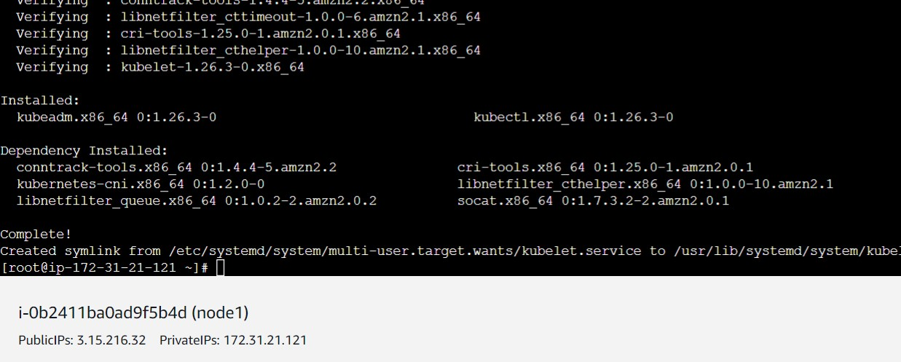

Step4 : Add node2 to Kubernetes Cluster by following same steps.
- Open node2 ec2 machine and Switch to root user
- # sudo -i
- Create a file called node2.sh and put following commands in it. And give execute permission to node1.sh file.
- Put these commands in the file and run it.
hostnamectl set-hostname node2
yum update -y
yum install git -y
amazon-linux-extras install java-openjdk11 -y
yum install docker -y
systemctl enable docker
systemctl restart docker

cat <<EOF | sudo tee /etc/yum.repos.d/kubernetes.repo
[kubernetes]
name=Kubernetes
baseurl=https://packages.cloud.google.com/yum/repos/kubernetes-el7-\$basearch
enabled=1
gpgcheck=1
gpgkey=https://packages.cloud.google.com/yum/doc/rpm-package-key.gpg
exclude=kubelet kubeadm kubectl
EOF
sudo yum install -y kubelet kubeadm kubectl --disableexcludes=kubernetes
systemctl enable kubelet
systemctl restart kubelet

- If the above file is executed successfully you will get this output on terminal for node2
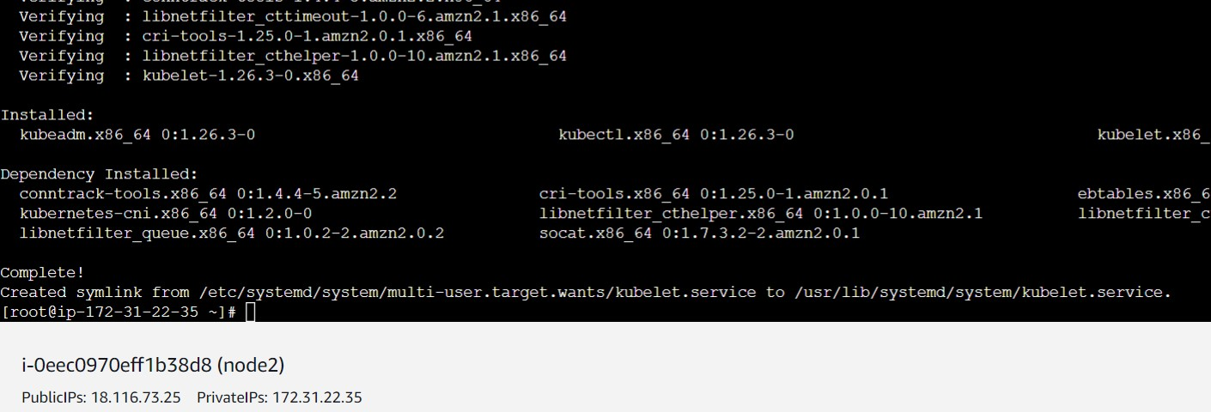
- Now run that Kubeadm join command on node1 and node2. (ONLY On NODE1 And NODE 2)
- After running join command on node1 you will get this.
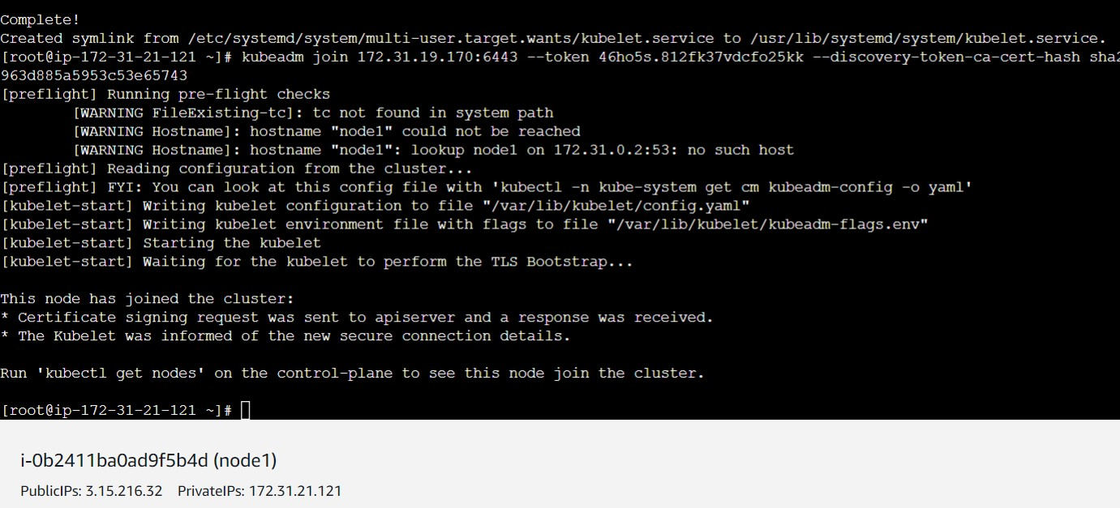

- After running join command on node2 you will get this.
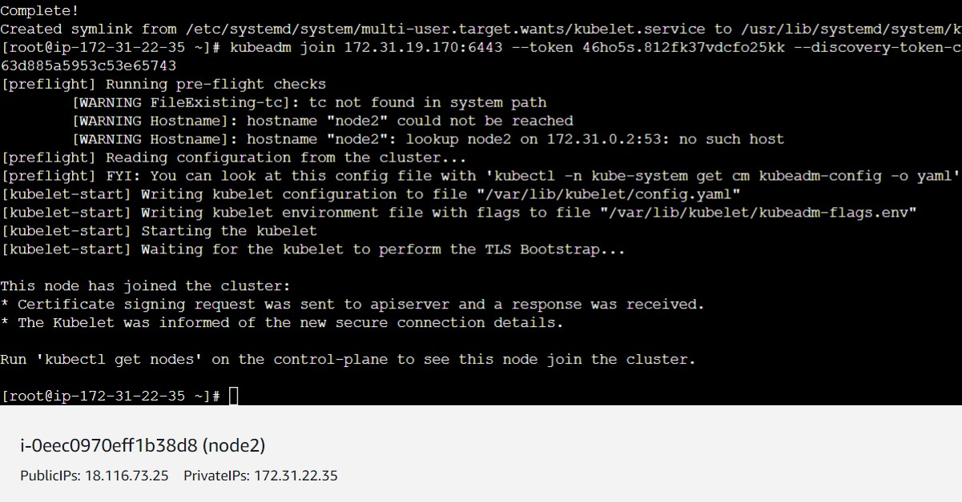
- Run the following commands on master node only
curl https://raw.githubusercontent.com/projectcalico/calico/v3.25.0/manifests/calico.yaml -O
kubectl apply -f calico.yaml
kubectl get nodes

- If all above steps followed correctly the cluster will be created and status will be changed to ready.

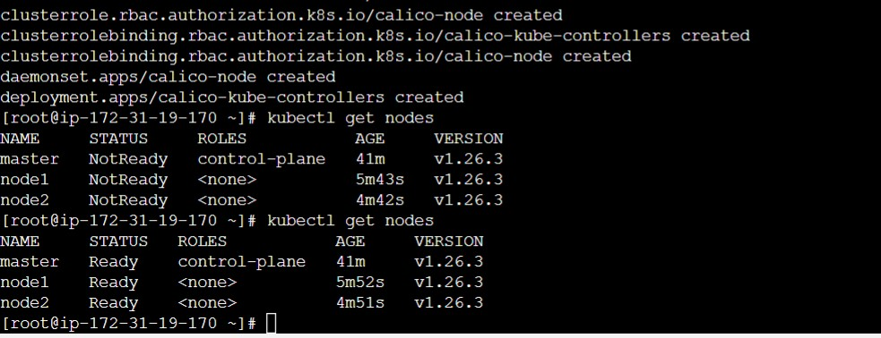

Step5 : Now lets download a project and deploy it on Kubernetes cluster.

- On Master node clone the project
- Create a project directory and run git clone command inside it
- git clone https://github.com/ramdassbhanage/fitpro-k8s-project-new-git2.git
- After cloning you will get ready microservices yaml files. You just need to run them.
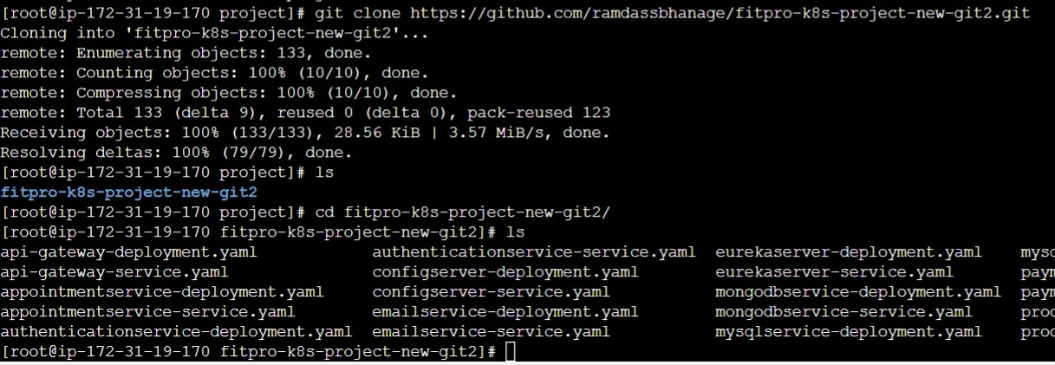
- Run the following command to deploy all the microservices to Kubernetes cluster
- kubectl apply -f .
- After running apply command project is deployed

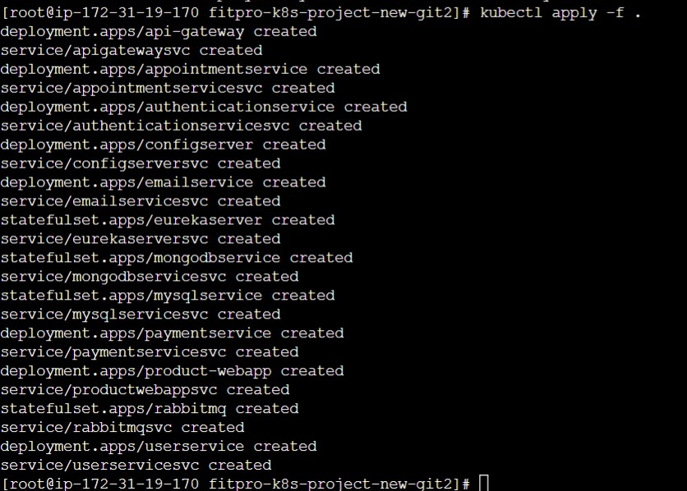
- Run the kubectl get pods command to list all pods
- # kubectl get pods
- Now run kubecl get svc command to list all ports information
- # kubectl get svc
- Copy 5 digit port of apigateway service and paste it in the browser with public ip of your master machine.
- Example : (http://3.16.169.169:30040/)
- You will this output

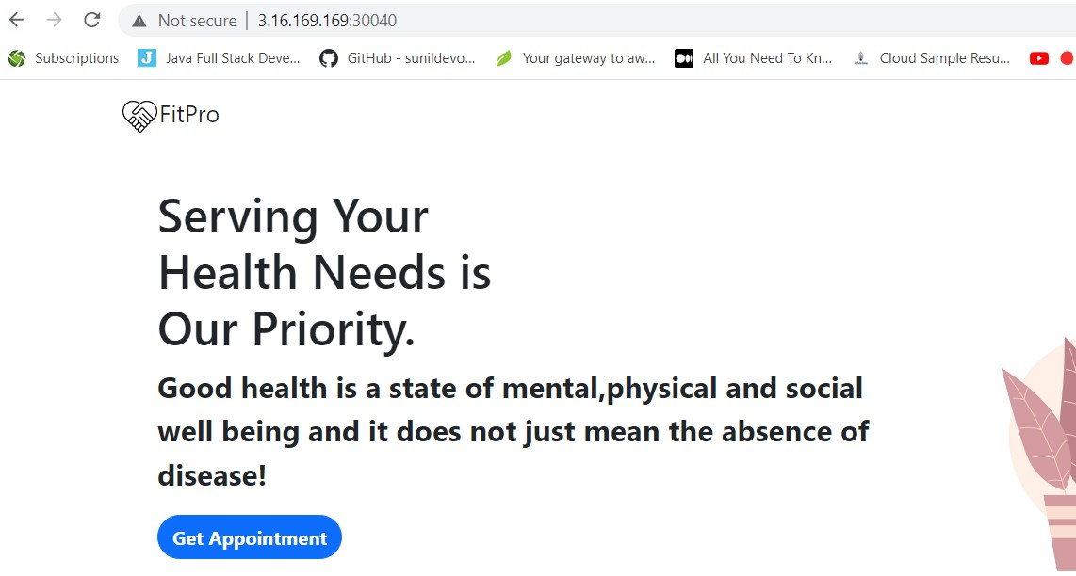
Installing Prometheus and Grafana
Steps to install Prometheus
Step 1 : Run these commands on master machine to install Prometheus
- Add the repository

sudo tee /etc/yum.repos.d/prometheus.repo <<EOF
[prometheus]
name=prometheus
baseurl=https://packagecloud.io/prometheus-rpm/release/el/7/x86_64
repo_gpgcheck=1
enabled=1
gpgkey=https://packagecloud.io/prometheus-rpm/release/gpgkey
https://raw.githubusercontent.com/lest/prometheus-rpm/master/RPM-GPG-KEY-prometheus-rpm
gpgcheck=1
metadata_expire=300
EOF

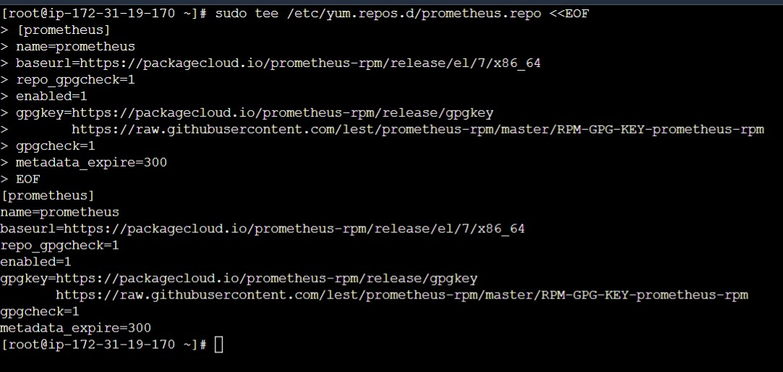
- Run these commands
# sudo yum -y install prometheus2
# systemctl enable prometheus
# systemctl restart prometheus
# systemctl status prometheus
# rpm -qi prometheus2
# sudo vim /etc/prometheus/prometheus.yml

Goto last line of Prometheus.yml file and add these lines

- job_name: 'K8s-master'

# metrics_path defaults to '/metrics'
# scheme defaults to 'http'.

static_configs:
- targets: ['localhost:9090']
# Pull host metrics with node exporter
- job_name: ‘node1’
static_configs:
- targets: [‘3.15.216.32:9100']
- job_name: ‘node2’
static_configs:
- targets: [' 18.116.73.25:9100']

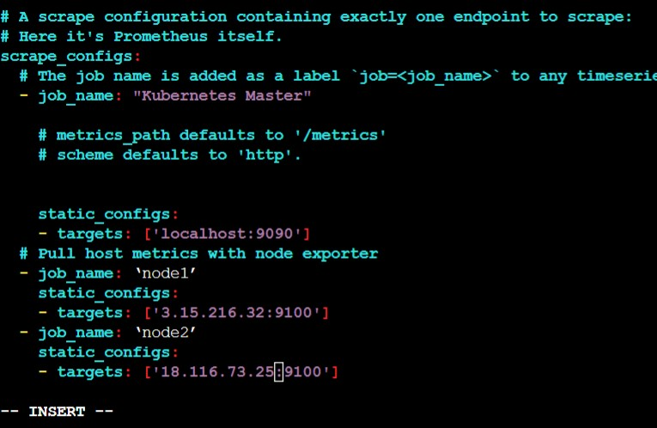
- Put public Ip address of node1 and node2 in local host
- After editing Prometheus.yml file restart it.
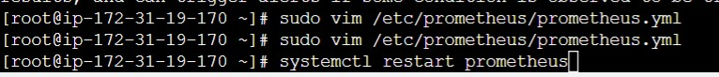
- # systemctl restart Prometheus
- Copy master node Public IP : 9090 and paste it in browser.

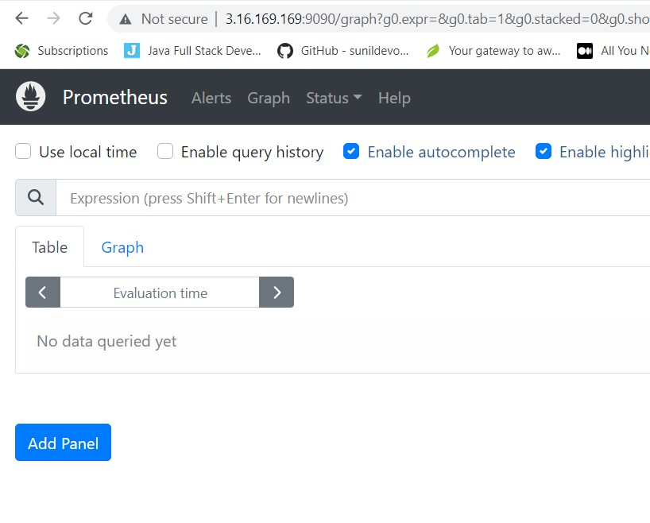

Step 2 : Install node exporter on node1 and node2
- Goto node1 ec2 machine
- Add the repository
sudo tee /etc/yum.repos.d/prometheus.repo <<EOF
[prometheus]
name=prometheus
baseurl=https://packagecloud.io/prometheus-rpm/release/el/7/x86_64
repo_gpgcheck=1
enabled=1
gpgkey=https://packagecloud.io/prometheus-rpm/release/gpgkey
https://raw.githubusercontent.com/lest/prometheus-rpm/master/RPM-GPG-KEY-prometheus-rpm
gpgcheck=1
metadata_expire=300
EOF

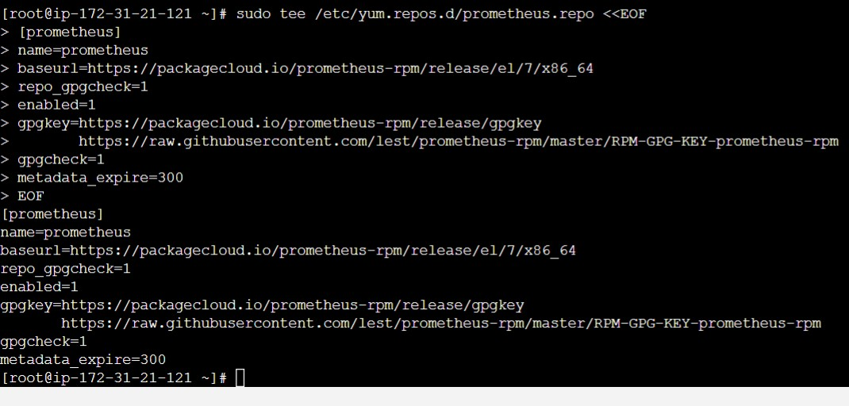
- Run following commands
- # yum -y install node_exporter
- # systemctl enable node_exporter
- # systemctl restart node_exporter
- # systemctl status node_exporter
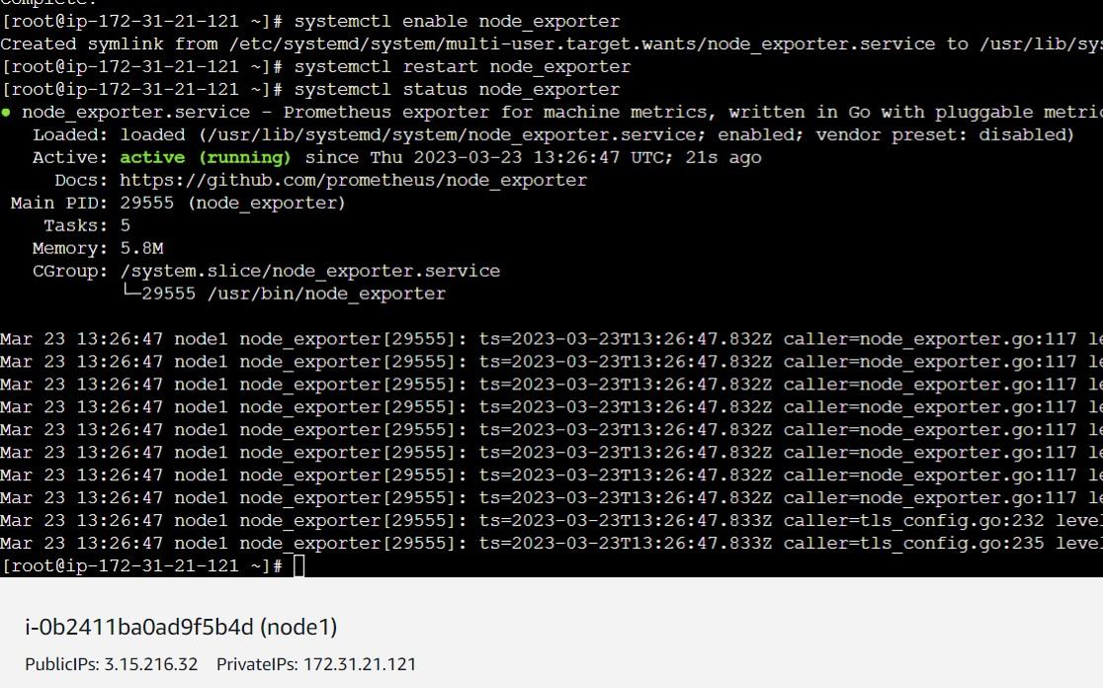

- Install node exporter on node2
- Add repository
sudo tee /etc/yum.repos.d/prometheus.repo <<EOF
[prometheus]
name=prometheus
baseurl=https://packagecloud.io/prometheus-rpm/release/el/7/x86_64
repo_gpgcheck=1
enabled=1
gpgkey=https://packagecloud.io/prometheus-rpm/release/gpgkey
https://raw.githubusercontent.com/lest/prometheus-rpm/master/RPM-GPG-KEY-prometheus-rpm
gpgcheck=1
metadata_expire=300
EOF

- Run following commands
# yum -y install node_exporter
# systemctl enable node_exporter
# systemctl restart node_exporter
# systemctl status node_exporter

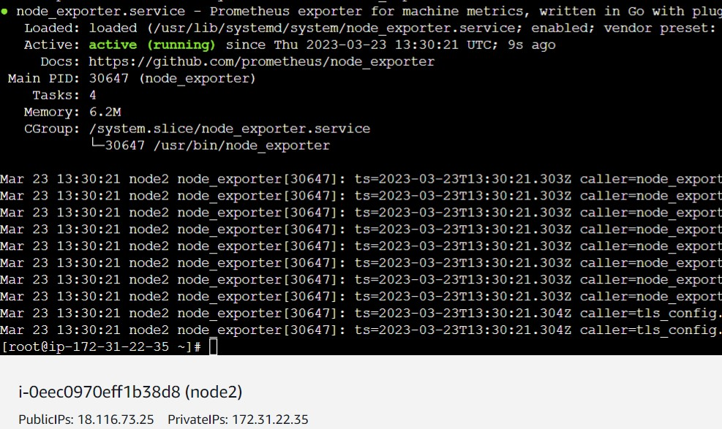

- Copy Node1 Public Ip and open it with 9100 port

http://3.15.216.32:9100/

- You will get this in browser

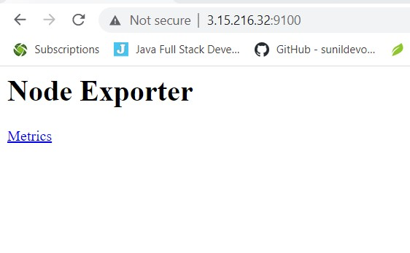

- Now copy master node puplic ip and open it with 9090 port and goto to targets

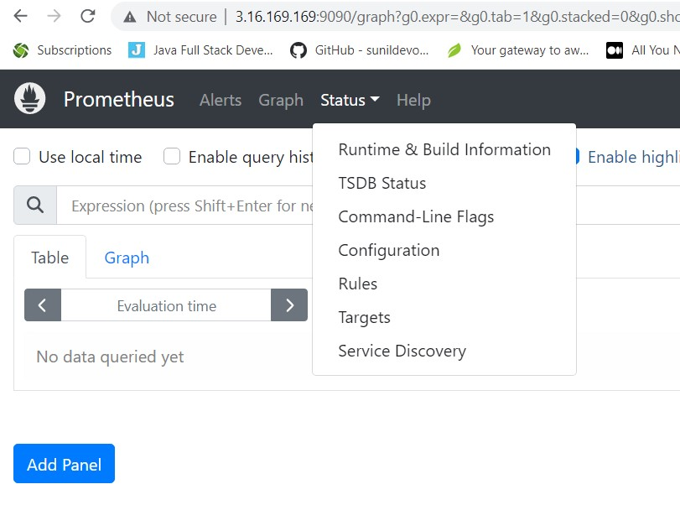

- Click on targets. It will display you node1 and node2 machine

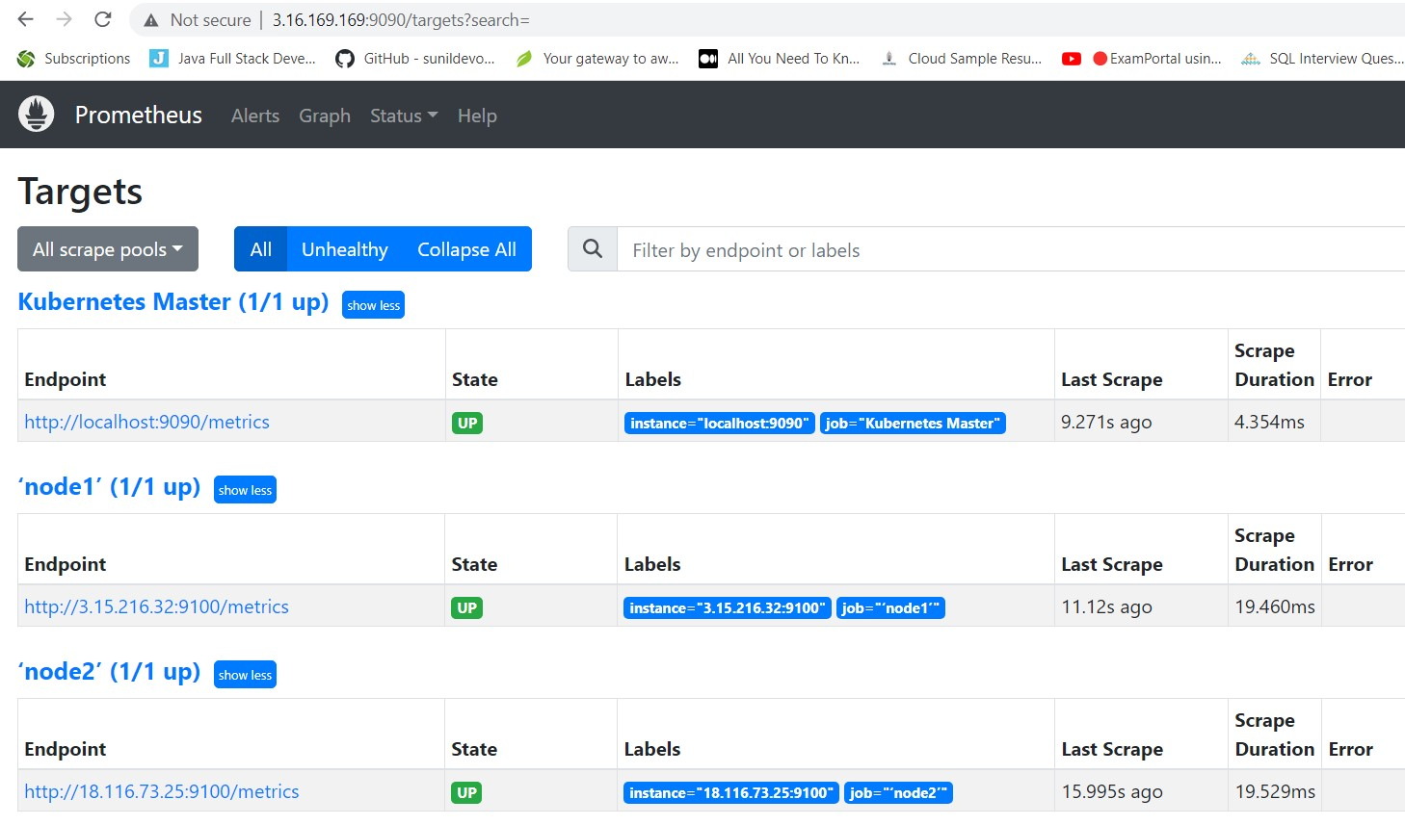

Step 4 : Installing Grafana on Master machine

- Create repo file
sudo vi /etc/yum.repos.d/grafana.repo

- Add following content in Grafana.repo file

[grafana]
name=grafana
baseurl=https://rpm.grafana.com
repo_gpgcheck=1
enabled=1
gpgcheck=1
gpgkey=https://rpm.grafana.com/gpg.key
sslverify=1
sslcacert=/etc/pki/tls/certs/ca-bundle.crt

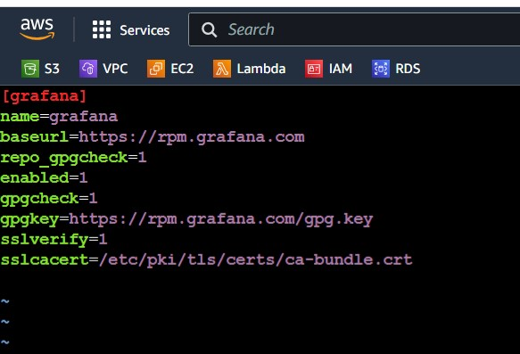
- Run following commands
- # sudo yum install grafana -y
- # sudo systemctl start grafana-server
- # sudo systemctl enable grafana-server
- # sudo systemctl status grafana-server

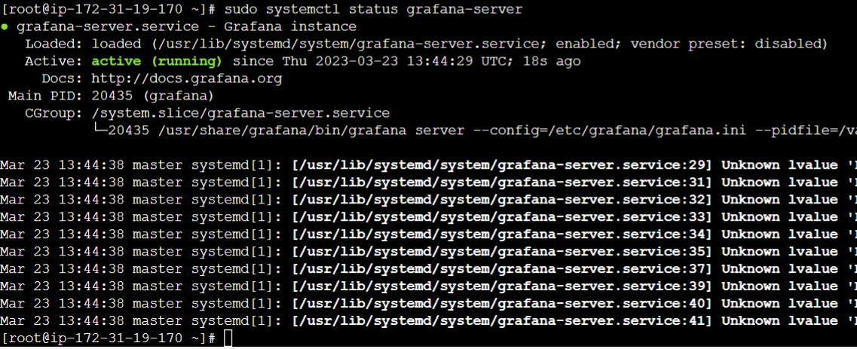

- Goto browser copy paste public IP of Master and 3000 port
- http://3.16.169.169:3000/

- You will see Grafana dashboard use admin and admin for username and password

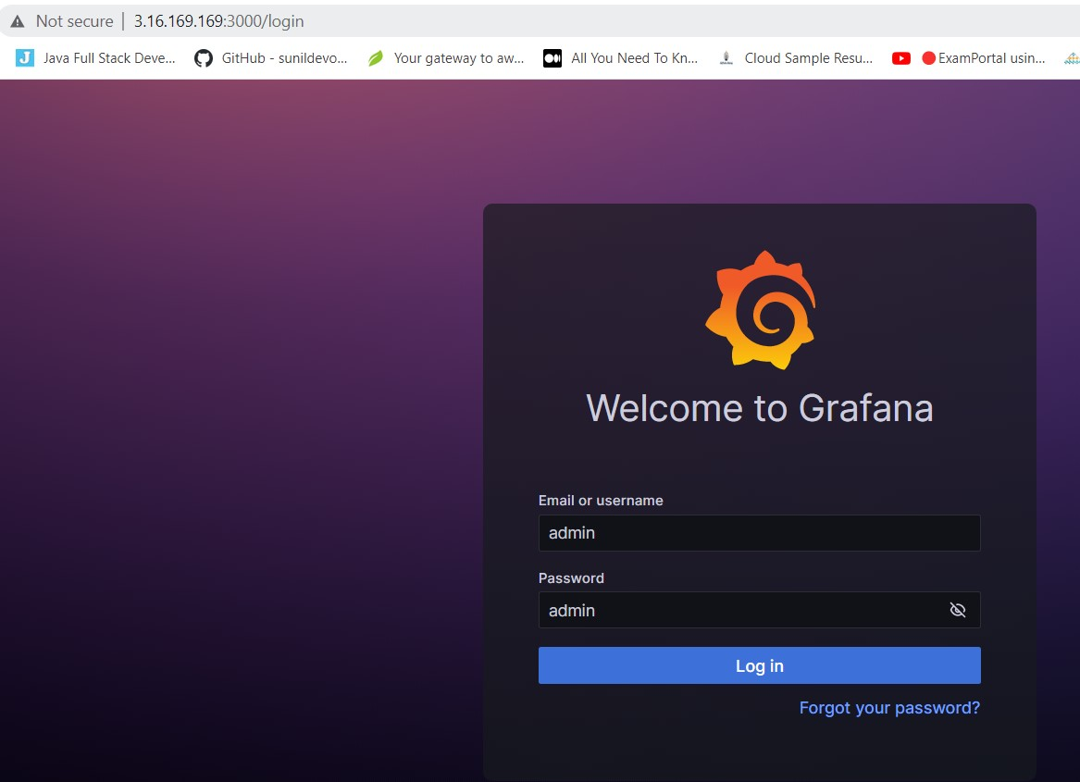

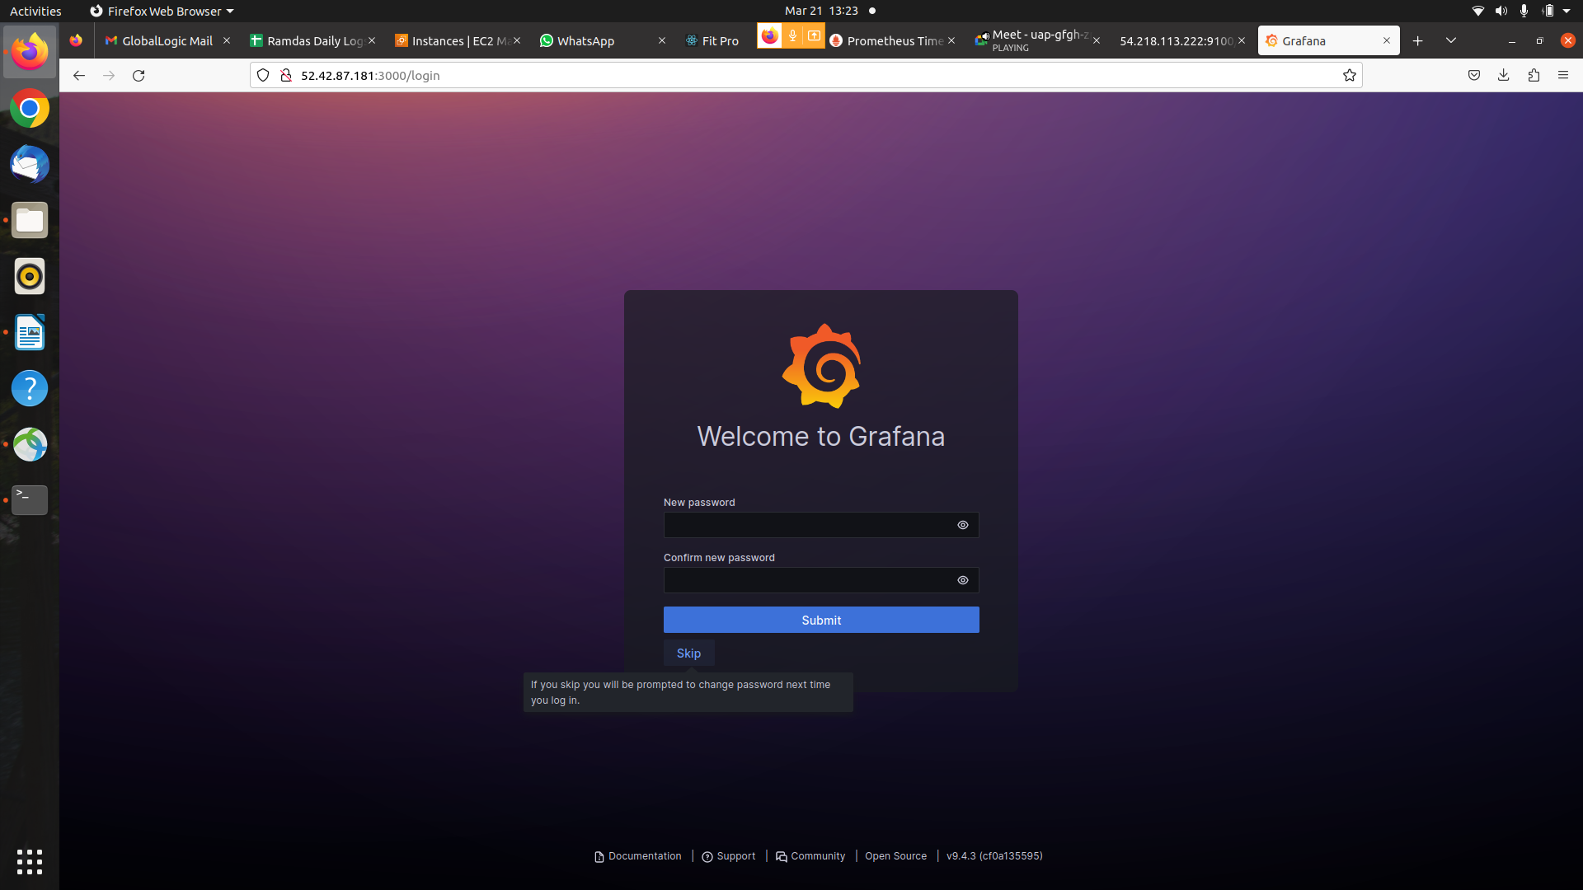
- Click skip if it ask to change password

- You will see Grafana dashboard & Data Souces

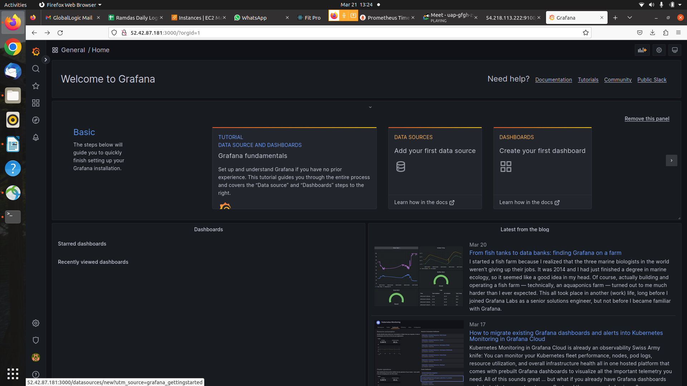

- You will see Add Data Source
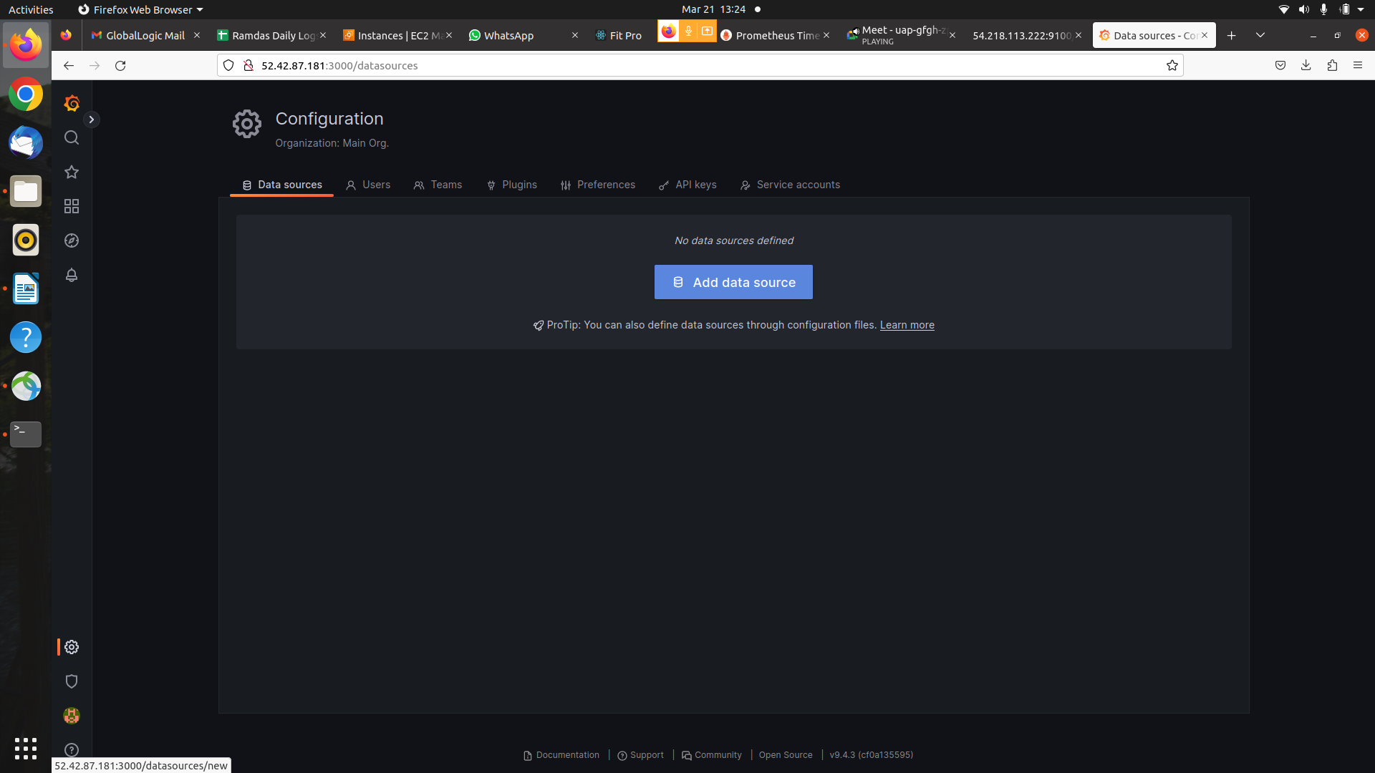

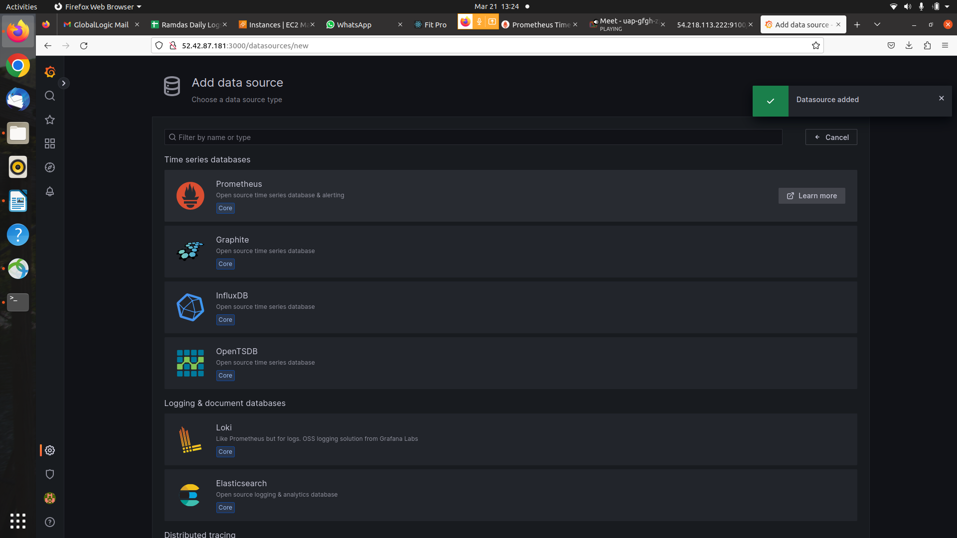
- You can select Prometheus Data Source and Click it.

- after change Configuration Add url i.e.http://localhost:9090
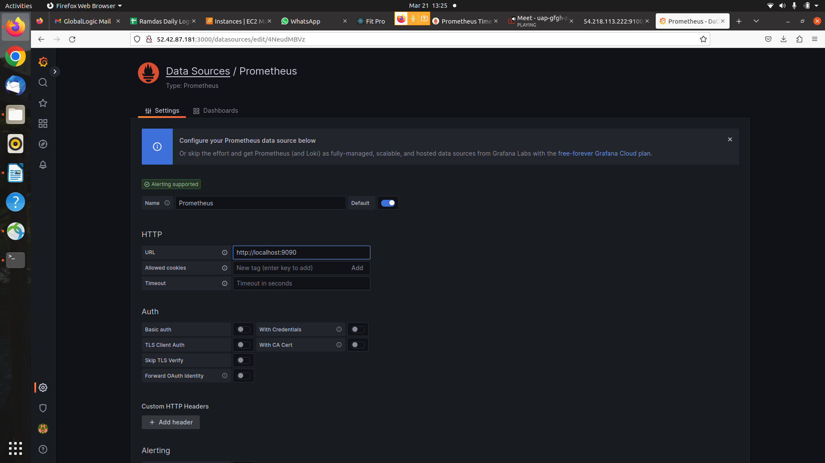

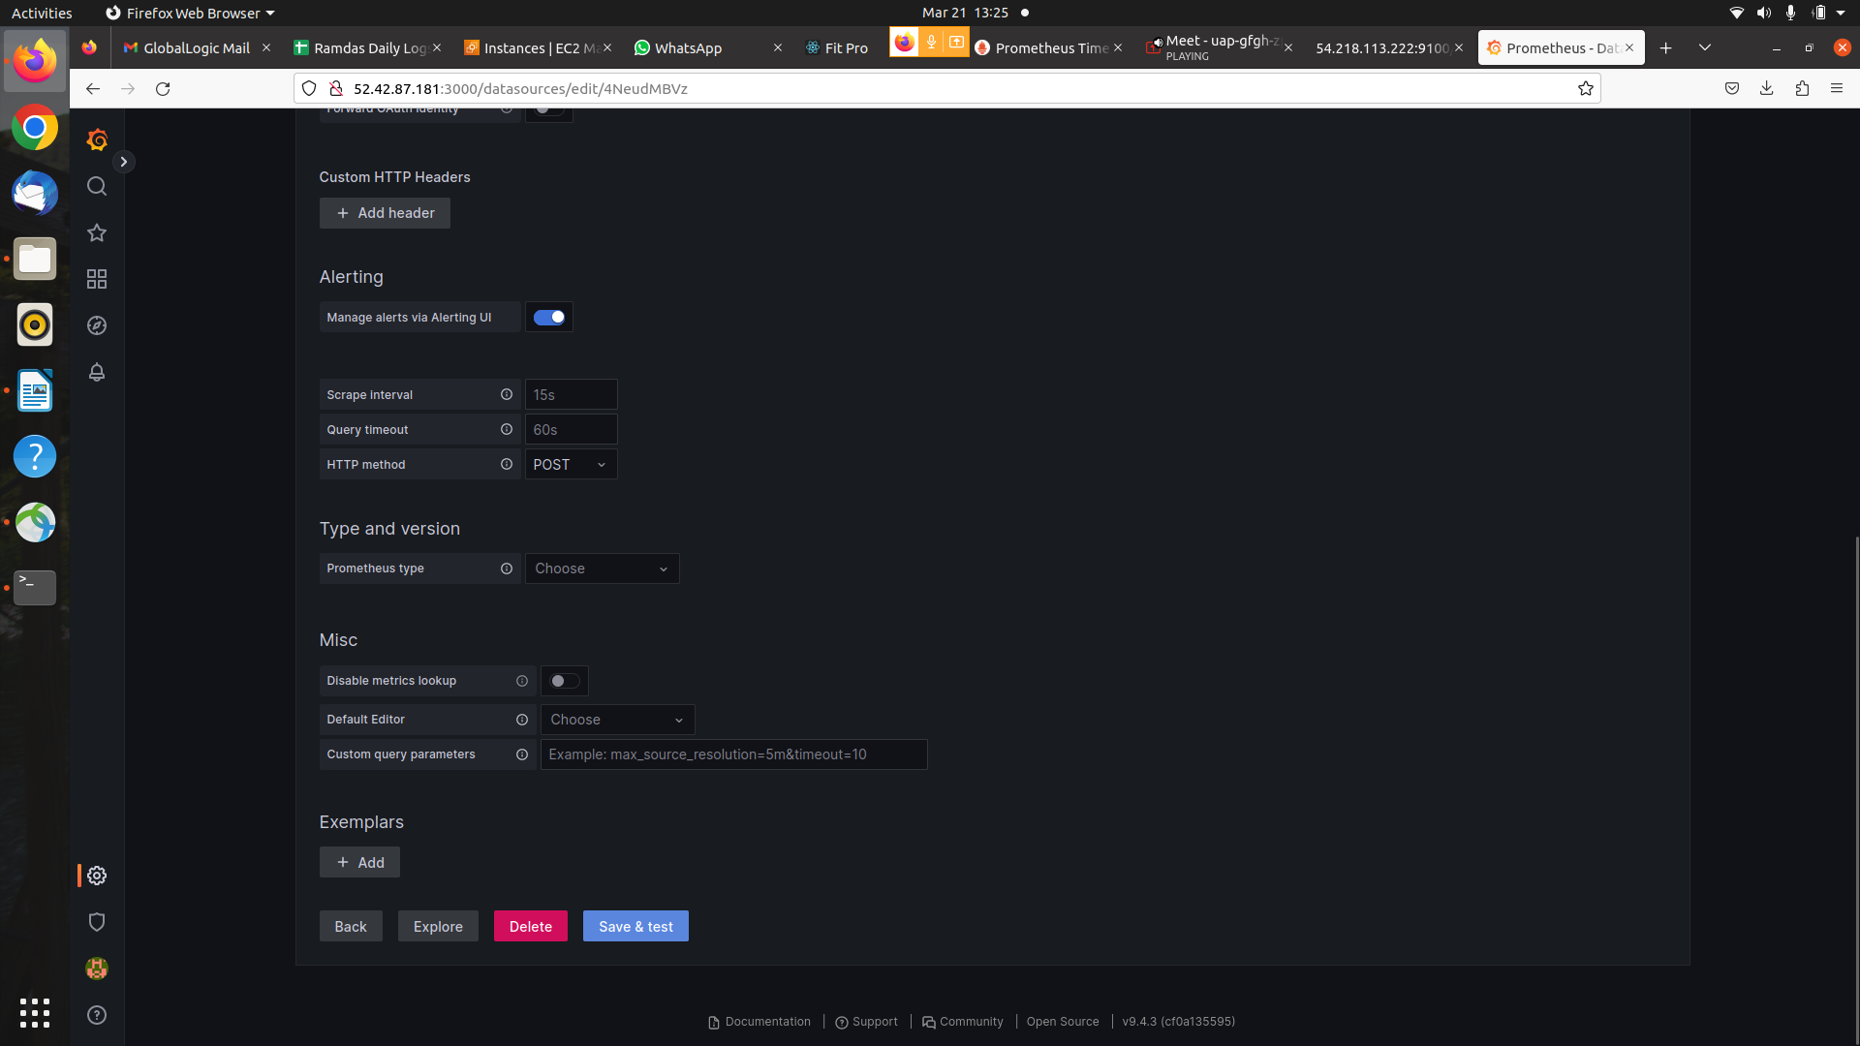
- then click save & Test.

- You will see DialogBox DataSource Added& Working.

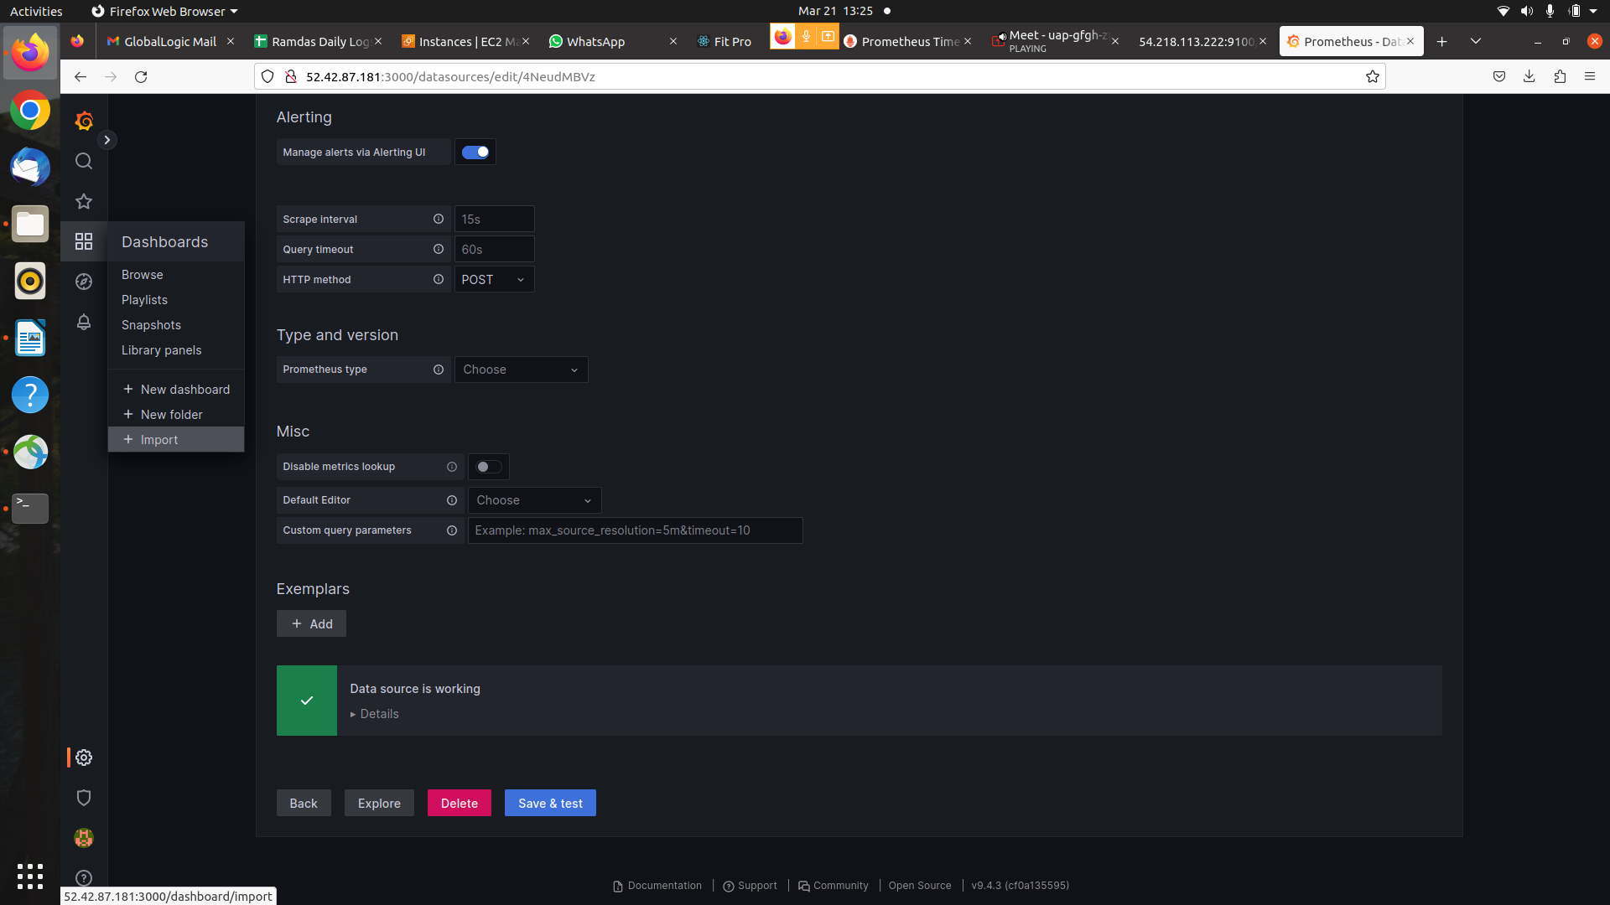
- you will see Dashobards /import dashboard add portno :1860 click Load.
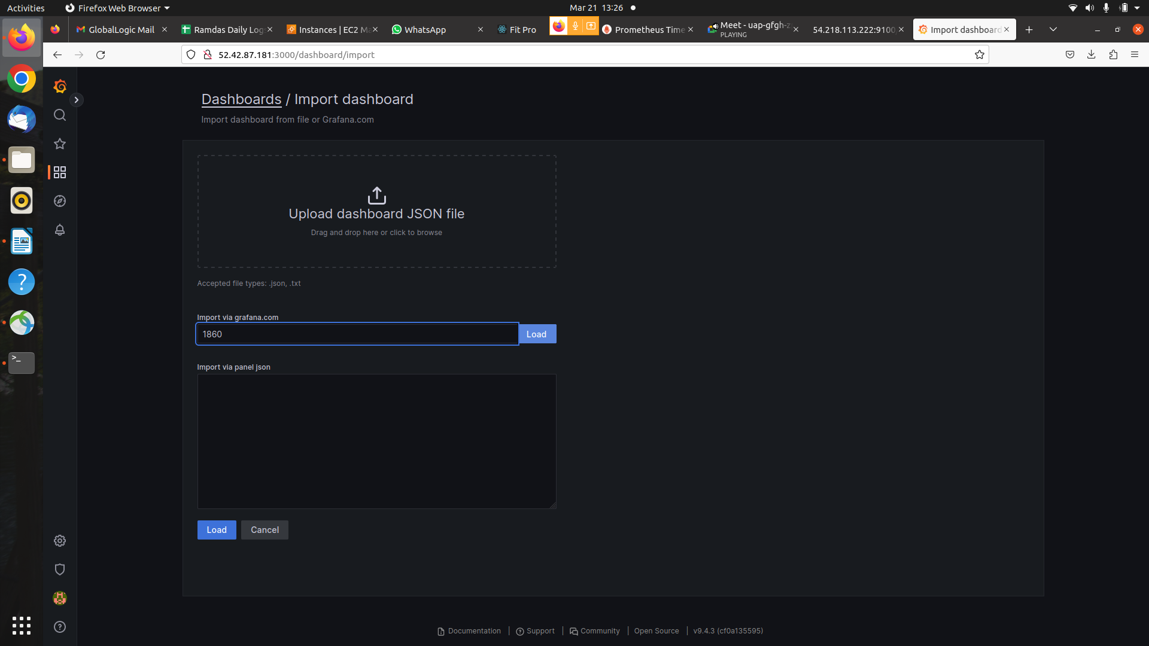

- you will see Dashobards /import dashboard select DataSource.

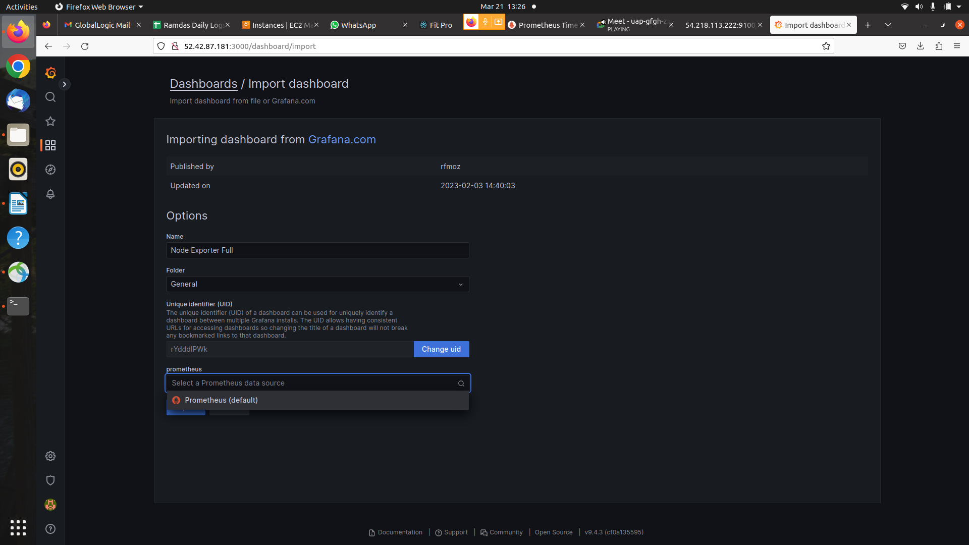

- you will see Node1 Dashboard Output.
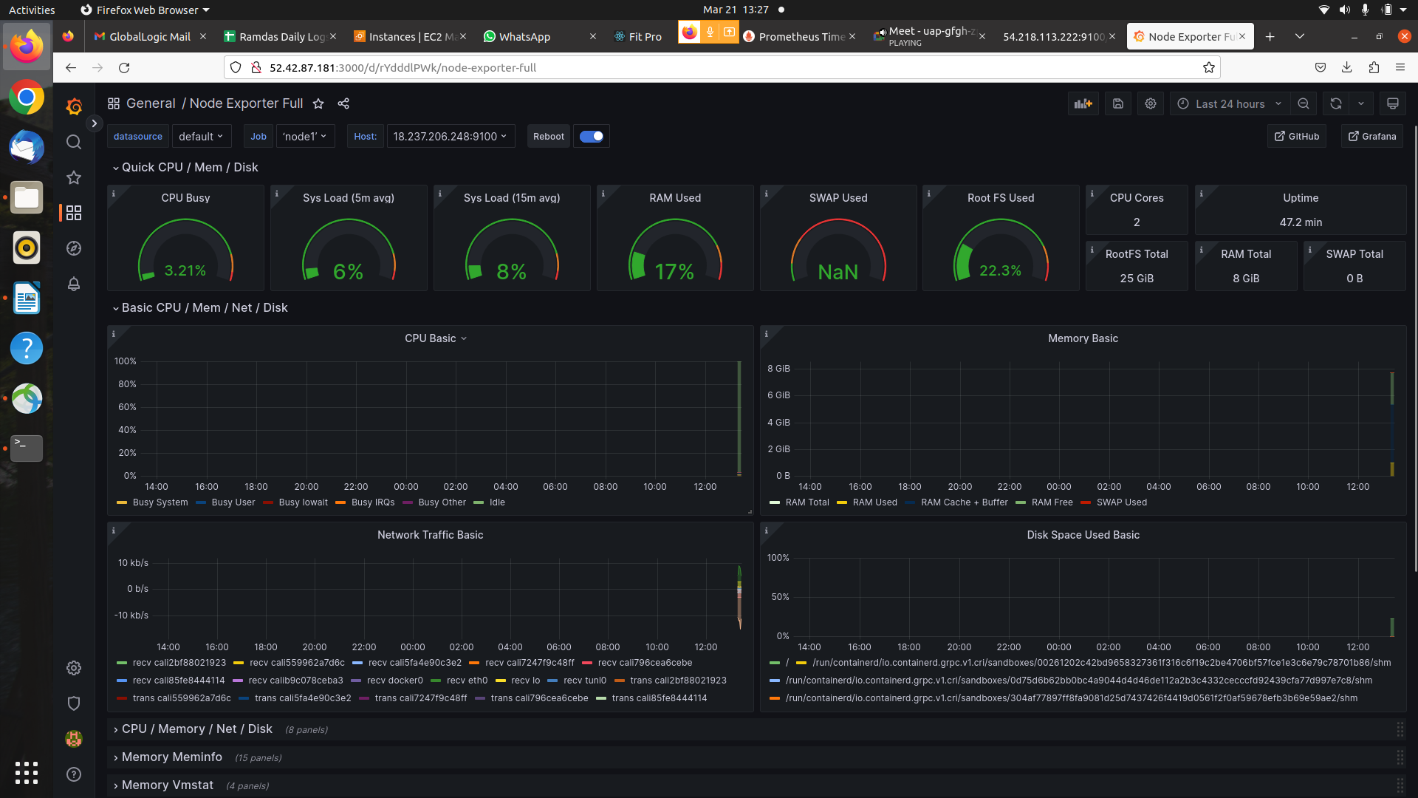

- you will see Node2 Dashboard Output.
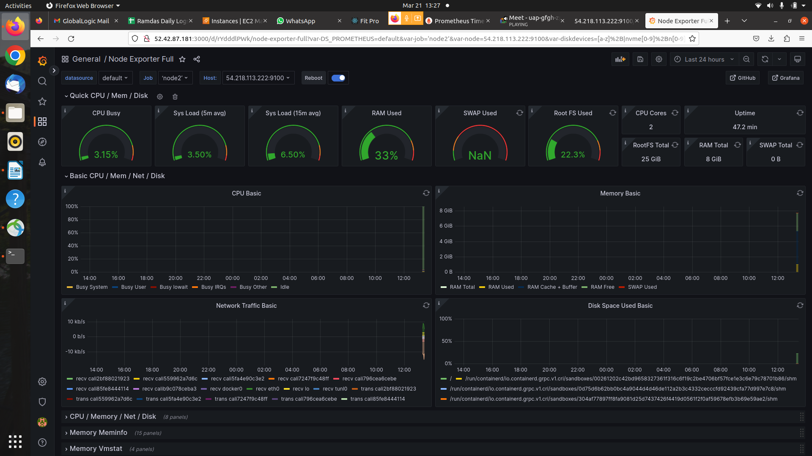

- you will see Node1 Dashboard Output For Time series last 5 min.

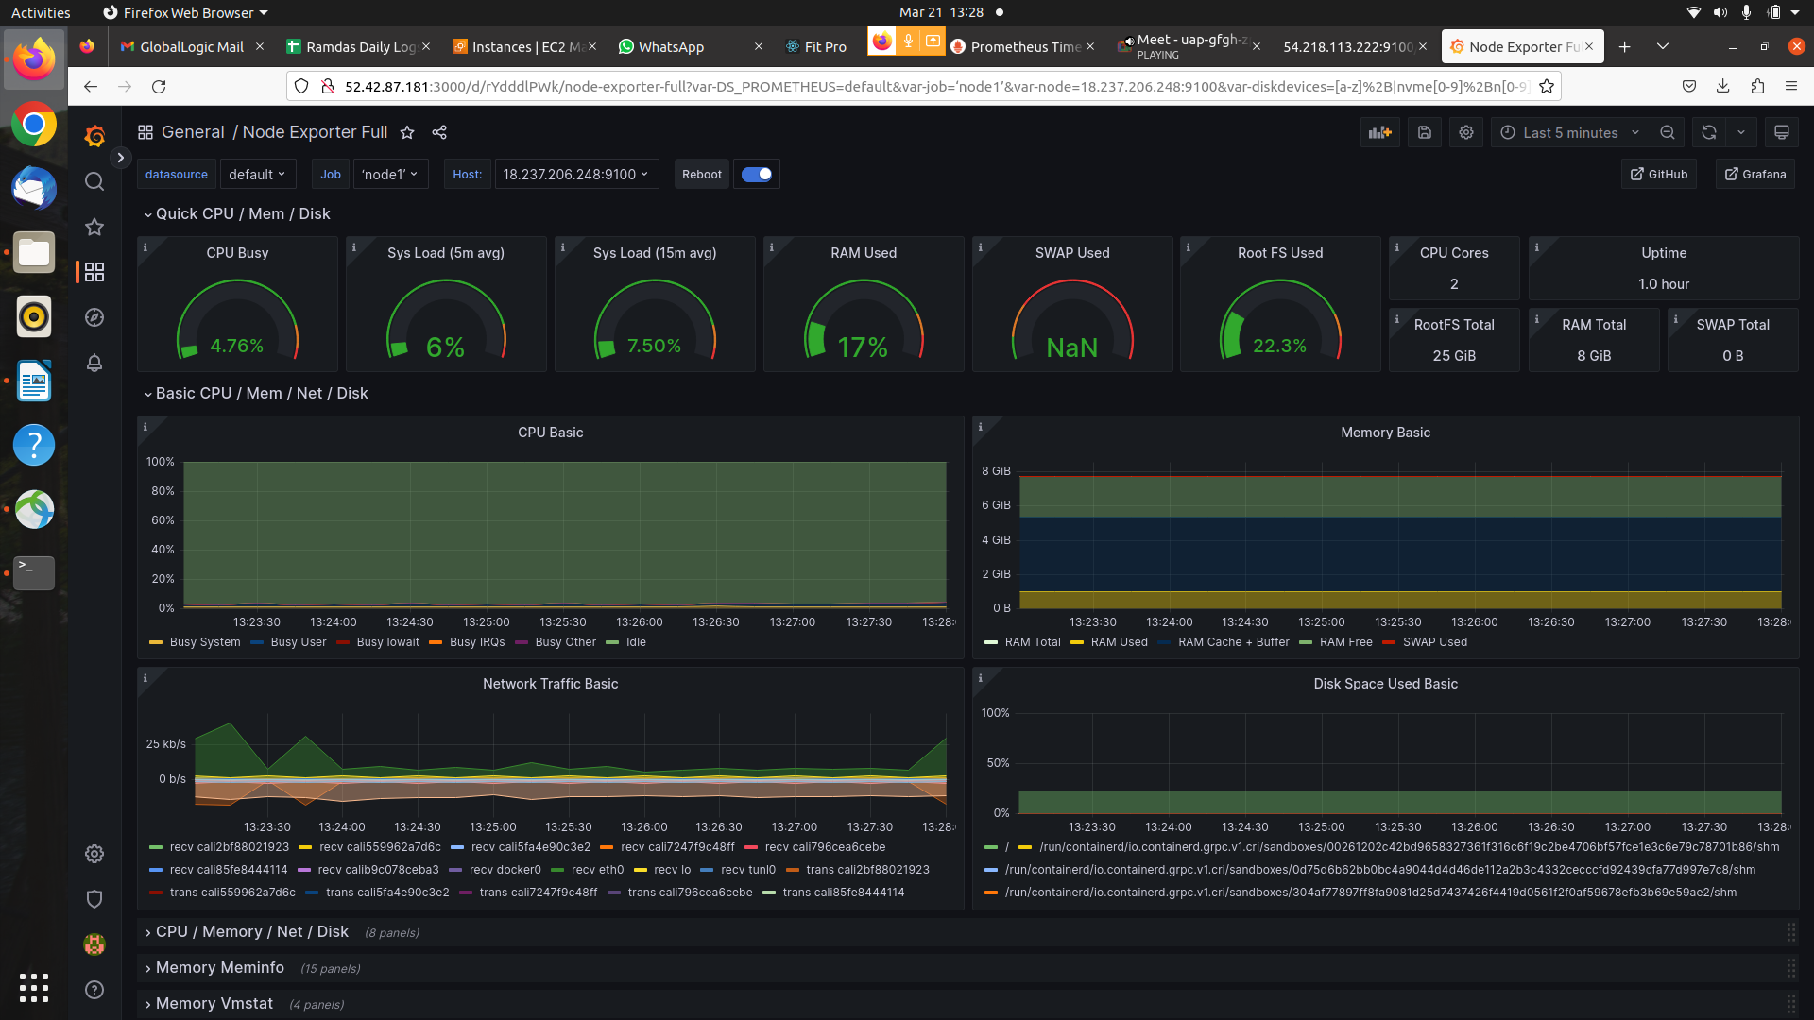

- you will see Node2 Dashboard Output For Time series last 5 min.


